The Board of Directors held a zoom meeting on August 23rd, 2021, at 7:00 pm to present the Traffic Study findings to the community and received written and oral questions during and after the meeting.

Below are the responses to the various questions that have been received by the Board of Directors to date.

Question 1: Why was the traffic study authorized?

- The existing roadways are showing the signs of wear and tear and need maintenance, especially near the three entrance and exit gates, as well as the adjacent roads which carry the most traffic, including heavy vehicles.
- There have been periodic complaints about vehicle speeding and the request for additional traffic calming.
- The repaving project to address the aging roadway within the community which is the largest project the association will undertake to date.
- To undertake a project of this magnitude the process to be followed based on industry standards and best practices are as follows:
  - Obtain a Traffic Study from a Certified Professional Engineering Firm
  - Obtain design plans from a Certified Professional Engineering Firm
  - Obtain permits from the required regulatory agencies (i.e., Miami-Dade County, DERM, etc.).
  - Obtain Construction Bids from a Certified General / Roadway Contractor for proposed work identified on the plans and select Contractor.
  - Repave roadways and implement all applicable traffic calming and safety improvements identified in the Traffic Study.

Question 2: Who authorized the traffic study?

- The Board of Directors authorized the study based the following:
- The condition of the existing roadways within the community, especially near the three entrance and exit gates, as well as the adjacent roads which carry the most traffic, including heavy vehicles.
- Identifying any safety issues and possible solutions
- Address issues that have been identified by homeowners
- To develop a budget for the proposed improvements
- Following the best practices, county and legal requirements.

Question 3: The traffic study was very extensive and included many options. Why was it so extensive?

- The Board of Directors asked the licensed Professional Traffic Engineer to include all options available to maximize all possible options to address the issues identified in the traffic study. If the community wishes to implement a traffic calming including speed humps, a traffic study prepared by a certified traffic engineer must be prepared and reviewed by the county.

Question 4: What was the cost of the traffic study?

- The cost of the traffic study was $12,800. There several were proposals with estimates between $15,150 to $18,000.

Question 5: When was this project discussed?
- It was discussed as part of the budget deliberations for the past three years. Also, periodically there have been written and oral requests to the Board of Directors over the years to address the speeding within the community.

Question 6: What does traffic control mean?

- Traffic control is an Engineering term that is used to identify various options to improve roadway safety and the behavior of drivers. This includes speed humps, rotaries / roundabouts, road narrowing, traffic signage, road markings, drainage and diverters/ raised medians.

Question 7: How far along are we on the process?

- We are at the beginning. The zoom presentation that was held on Monday August 23, 2021, evening was the first presentation to the community in which several options were presented. To date, the Board of directors have made no decisions and there will be a three-month period for the community to provide written and oral comments on the recommendations made in the traffic study.

Question 8: Will there be an opportunity for individual meetings?

- Yes, call the main office and Tere or Al will schedule a meeting with a sub-committee of the board.

Question 9: There were several comments made concerning the diverters. There was very little support of this option.

- The Board of Directors appreciates all input and will take the community objections into consideration. The fact that our streets are narrow at a 22 feet width which makes the use of diverters limited. Nevertheless, traffic diverters are a potential alternative that are being considered as a possible and the appropriate size will be evaluated during the final design phase in which the Engineer will determine if diverters are viable.
- Additional traffic calming features that are being considered but not limited to:

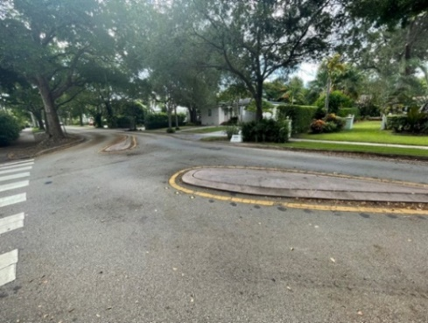
- Smaller Diverters

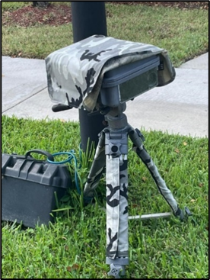
- Traffic Hawk System: Provides automatic speed enforcement through radar and sends a speeding warning or violation to the house vehicle that is registered with the Association.

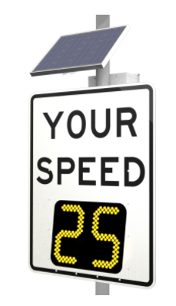

- Speed Feedback Sign: Sign that lights up with current speed to allow drivers to correct their speed if they are above the limit.

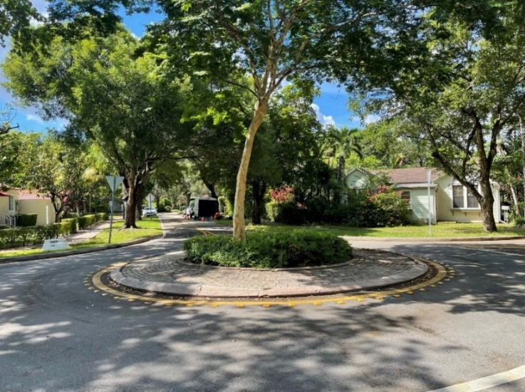
- Roundabouts:

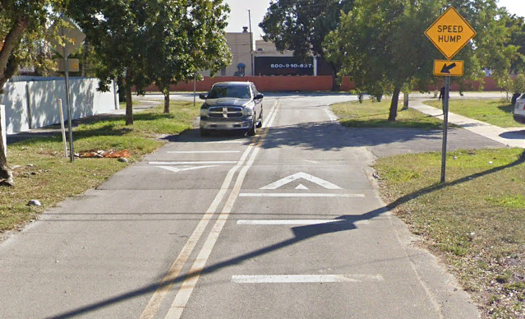
- Speed Humps:

Question 10: The written comment was received suggesting keeping the existing speed bumps and adding speed humps in addition.

- The preferred method of re-paving is milling and resurfacing of the existing roads within the community. Milling and resurfacing is the removal / grinding a minimum of 1-inch of the existing asphalt pavement and replacing with a new 1-inch layer of asphalt pavement. The removal of the 1-inch of asphalt pavement will also remove the existing speed bumps within the community.
- Many of the existing speed bumps are not compliant in their existing shape or their location. There are many existing speed bumps that are very close to intersections which is not desirable.
- Once the final design plans are submitted to Miami-Dade County for permit, the existing bumps will be required to be removed due to being outdated and non-compliant with current standards.

Question 11: There were comments expressing concern about the cost of the traffic study.

- The cost is unavoidable, if the association is going to comply with best practices and county requirements.
- The cost of the design and the repaving of the roadways will be funded from reserves that have been set aside for this project.

Question 12: Are there enough funds in reserves to pay for the project?

- It will depend on the final design. The final cost of the project will not be known until the design is completed at the second phase of the project and bids received from various contractors for this project. Currently, the construction industry is experience cost increases due to labor and material shortages that would affect the overall cost of the project in the future.
- The board will review the available funds and the costs to determine if the project can be done all at once or if the project will be constructed in several phases based on the available funds.

Question 13: Why are the police officers no longer providing traffic enforcement services.

- FHP stopped providing these services during the height of the Covid crisis.
- FHP has been contacted periodically to monitor when they were open for business. They will provide the services but will only issue warnings.
- The HOA is in the process of coordinating with Miami Dade County Police Department to provide traffic enforcement services.

Question 14: Is SW 118th Passage long enough to have a speed hump.

- We will ask the Traffic Engineer to verify that all streets comply with the Miami Dade County standards and determine if a speed hump can be placed along SW 118th Passage. The street must be 750 feet without intersecting street to be considered for a speed hump.

Question 15: There was a concern about access for emergency vehicles.

- There is a separate project in process to address the concern raised by Fire Department and Police personnel when attempting to enter the community through the SW 125th Avenue entrance. The large fire trucks cannot enter community due to the existing configuration of the entrance at the gate and navigate the roundabout safely. In fact, on August 25th, 2021, a Fire Department ladder truck attempted to enter the community through the SW 125th Avenue gate and the rear end of the vehicle could not make the turn. Present standards regarding roundabouts require a raised truck apron buffer zone. This project will modify the existing roundabout to meet current design standards and will be able to accommodate large emergency vehicles. The apron front mountable curb will be 3” tall allowing larger vehicles to mount the curb and utilize the raised apron to navigate the roundabout. This will be further discussed at our September 2021 meeting.
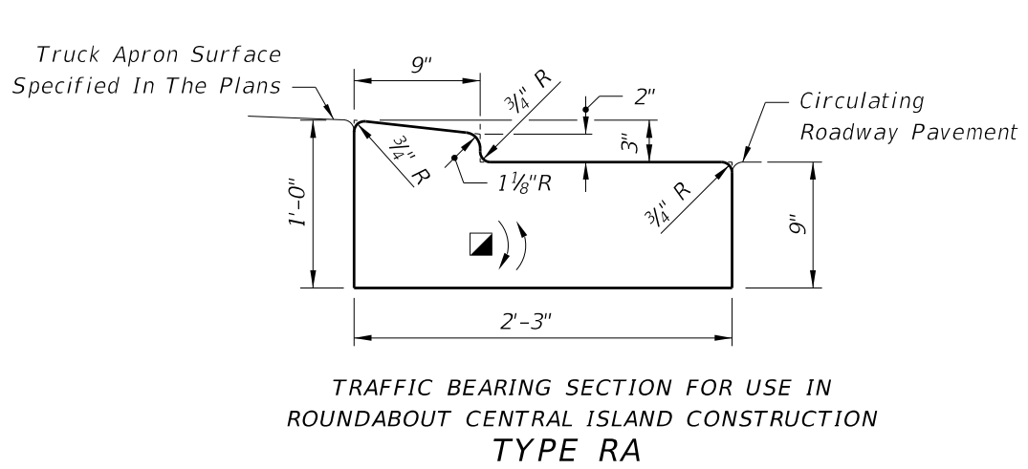

Question 16: A resident living on SW 133rd Terrace reported that during our meeting there was no traffic on her street and questioned the need for expensive solutions.

- The vehicle counts on the north, east and west sides of the third lake are extremely low. Slightly over 100 vehicles a day for the location discussed. We will ask the consultant to look at those locations.
- SW 133rd Terrace has one of the lowest volumes out of all the counted locations.
- It should be noted that the Traffic Study encompasses the entire community, and some recommendations may impact more than one location. All recommendations will be evaluated to determine which would result in a safer community for the residents.

Question 17: Why is there no speed hump being considered for SW 119th Avenue.

- The road is not long enough and does not meet Miami-Dade County standards for a speed hump. Our Traffic Engineer was asked to look at all alternatives to address safety and speeding issues throughout the community which included SW 119th Avenue.

Question 18: Would we be liable for any damage to vehicles incurred by the speed humps.

- The HOA will not be liable. The design and installation of speed humps will be based on current State of Florida and Miami-Dade County design criteria and will be designed by a licensed Professional Roadway Engineer. Any vehicle conforming to legal standards and obeying traffic laws will be able to pass the speed hump.

Question 19: Why is there no landscaping being recommended?

- This is a traffic study which identified safety issues within the community and provided recommendations to address the issues. In the next phase of the process as part of the roadway design, landscaping will be considered at that stage of the project.

Question 20: A suggestion was made to use traffic enforcement to address the 15% of the people not complying with traffic laws.

- The 85th percentile speed was found to be approximately 25 mph at most locations. This means that 85% of vehicles are traveling at or below 25 mph. There is between 50-60% of vehicles traveling over the posted speed limit of 15 mph. The HOA is currently coordinating with Miami-Dade County Police Department for traffic enforcement. However, law enforcement is in the community for a limited number of hours each month which will not address the 15% of drivers that are not driving at the required speed limit within the community.

Question 20: Why is the repaving not included in this study?

- This study was a traffic study which identified safety issues and made various recommendations to address these issues. However, as part of the study a conceptual cost was provided for the milling and resurfacing of the roads within the community was provided. The actual milling and resurfacing of the roads in the community will be address as part of the final design which will be developed by a Professional Roadway Engineer.

Question 21: What does the 85th percentile mean?

- The 85th percentile speed is an industry standard. This is the speed at which 85th percentile of the vehicles is travelling at or below. In the case of this community, it was observed to be at 25 mph which means 15% of vehicles are travelling above this speed limit and 85% are below. This is used for warranting speed humps, which according to Miami-Dade County criteria requires the 85th percentile speed (in this case 25 mph) to be 10 mph above the posted speed limit (15 mph for the community).

Question 22: There were many comments about the cost of the project.

- The final cost of this project has not yet been determined and will not be finalized until the final design has been completed and bids received for Certified General / Roadway Contractors. A preliminary cost has been developed for budgeting purposes based on the engineering and construction industry estimating standards.

Visit our website at www.bonitalakes.org to hear the presentation, or any board meeting this year.

The responses above should address all the questions received from the community regarding the traffic study. PLEASE PROVIDE ANY ADDITIONAL COMMENTS TO THE OFFICE AS SOON AS POSSIBLE IN WRITING, VIA E-MAIL (bonitalakes1@comcast.net), BY PHONE (305-253-6280) OR IN PERSON AT THE OFFICE.

